# **Template – Change of Grade Form Sequence**

The template named “Template – Change of Grade Form Sequence” is applicable to CampusNexus Student.

## Purpose and Outcome

This template provides a form sequence and supporting workflow for a form sequence to be completed by staff members to change a student’s grade and digitally sign the Change of Grade form.

The sequence requires the following:

* A complete **Staff record** must exist in the CampusNexus Student database.
* The staff member must have **Staff credentials** to log into this authenticated sequence.

The workflow looks up the Staff, Student, Course, and Enrollment entities, updates the student’s grade and generates a PDF of the completed Change of Grade form.

## Prerequisites

The template was built with Forms Builder using the applications listed below. The template is forward compatible with later versions of the listed applications.

|  |  |
| --- | --- |
| **Application** | **Minimum Version** |
| Forms Builder Designer and Renderer | 3.6.x |
| Web Client for CampusNexus Student | 20.0 |
| Workflow Composer | 3.0.x |
| Packages installed from Package Manager in Workflow Composer | Activities and Contracts (V1) 20.0.0  Activities and Contracts (V2) 20.0.0  Forms Builder Contracts 3.6.x |
| Workflow Tracking Database | N/A |
| Staff STS 2.0 | 2.1 |

## Step 1: Download and Import the Template

1. Download the template file to your environment (local drive or network location).
2. Log into **Forms Builder Designer**.
3. Click the **Export/Import** tile.
4. Select the **Import** tab.
5. Click **Select exported file** and navigate to the downloaded template file.
6. Click **Import**.

* [Export/Import](https://help.campusmanagement.com/FB/3.x/Content/ExportImport.htm)

The following forms will be imported::

* Grade Change Form
* View Summary
* Custom - Confirmation Standard No Auto Close

## Step 2: In Form Designer…

1. From the **Forms** slide out, select the **Grade Change** **Form**.
2. Customize the form for your environment. Modify properties on fields/components to make them required, etc., or add/remove fields on form.

Make sure you edit the text in the Labels and HTML controls as applicable for your institution.

* [Fields](https://help.campusmanagement.com/FB/3.x/Content/Fields.htm) and [Components](https://help.campusmanagement.com/FB/3.x/Content/Components.htm)

1. **Save** the form.
2. Repeat steps 1-3 for the View Summary and Custom - Confirmation Standard No Auto Close forms.

## Step 3: In Sequence Designer…

1. Locate the **Change of Grade Form Sequence** in the Sequences pane.
2. Click **Save As** to create a copy of the sequence/workflow and customize the copy for your use. This way you can always refer to the original sequence/workflow you downloaded.
3. Optional - Add a custom style (theme) associated with your campus.

* [Themes](https://help.campusmanagement.com/FB/3.x/Content/Themes.htm)

1. Select your saved sequence in the Sequences pane.
2. In the Properties Pane, select **End State Form** “Custom - Confirmation Standard No Auto Close”.
3. **Save** the sequence**.**

## Step 4: In Workflow Composer…

1. Open the workflow for your saved sequence.

* [Opening Workflows for Sequences](https://help.campusmanagement.com/FB/3.x/Content/HostedEnv.htm)

1. Explore the arguments, states, and transitions to get an understanding of the workflow logic.
2. In the **Submit** transition, locate the **ExecuteODataQuery<StudentCourseEntity>** activity and edit the host name for your CampusNexus Student environment.

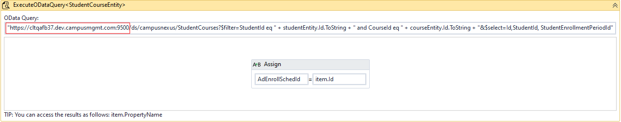

**Note**: If you are using CampusNexus Student 21.2 and later, the ExecuteODataQuery<> activity requires the APIUser to have access to any of the entities referenced in the query. See <https://help.campusmanagement.com/wf/Content/Workflow/ODataAuthorization.htm>

1. Further down in the Submit transition, in **CreateDocument** activity, set DocumentType and DocumentStatus to correct values for your environment (OnFile is recommented for DocStatus).

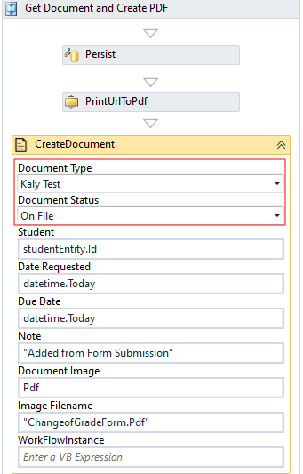

## Step 5: In Forms Renderer…

Select your sequence and try it out!

* [Sequence List](https://help.campusmanagement.com/FB/3.x/Content/SequenceList.htm)

1. Find your **Change of Grade Form Sequence** and copy the **URL** to the clipboard.
2. Paste the URL into a browser and complete the form sequence.
3. In CampusNexus Student, verify that the staff member’s address information is updated as specified in the form sequence.

## Step 6: Lastly…

Once your updated sequence has been tested successfully, it is recommended that you disable the workflow for the original Template version.

1. In Workflow Composer, in the Server section of the ribbon, click **Open**.
2. Find the workflow named **Change of Grade Form Sequence**.
3. Clear the **Enabled** check box and click **Save**.